The DDDEvent model

Thomas Skaugen, HM/NVE

1. **Introduction**

The DDDEvent (Distance Distribution Dynamics Event) model is a catchment scale rainfall- runoff model which starts its simulation from drawn subsurface states, drawn precipitation values and drawn precipitation sequences. The values are drawn from specified parametric statistical distributions.

The DDDEvent is a simplified version of the DDDv2 model and simulates runoff from permeable and impermeable areas, both subsurface and overland flow. The current version ignores evapotranspiration and does not include snowmelt as input. Features of the DDDEvent:

### 1.1 The model simulates the hydrological dynamics (routing) of:

-Permeable areas (P)

-Impermeable areas (IP)

-RiverNetwork

### 1.2 Additional features

- Infiltration capacity for P and IP areas

- Subsurface moisture accounting is carried out for the catchment using a 2D (hillslope) representation of subsurface soil moisture.

- The model starts from specified groundwater states

The flow dynamics for the features in 1.1 are carried out using distance distributions and celerity (velocity) estimates in the construction of unit hydrographs. The unit functions**/transfer functions**/unit hydrographs are used to distribute the impulse in time to the recipient. Impulse can typically be rainfall on the hillslope, whereas the recipient is the river network. The job of the transfer function is to describe the temporal distribution of the hillslope runoff to the river network. Another transfer function will describe the temporal distribution of the flow in the river network.

The catchment in DDDEvent is divided according to which landscape types (Lst) have storage capacity. In the DDDEvent model these Lsts are permeable areas (P) and impermeable areas (IP). The river network is just represented by its transfer function (se paragraph above).

Figure 1, The structure of DDDEvent.

## Set-up, prerequisites and running the model

The DDDEvent model is coded in Julia (download Julia from <https://julialang.org/>) and can be edited in Jypyter notebooks (hereafter called «notebook»), in Notepad ++, or in Visual Studio Code.

Download Julia and Jypyter, and open Julia and write in the Julia window: “import Pkg; Pkg.add("IJulia") “

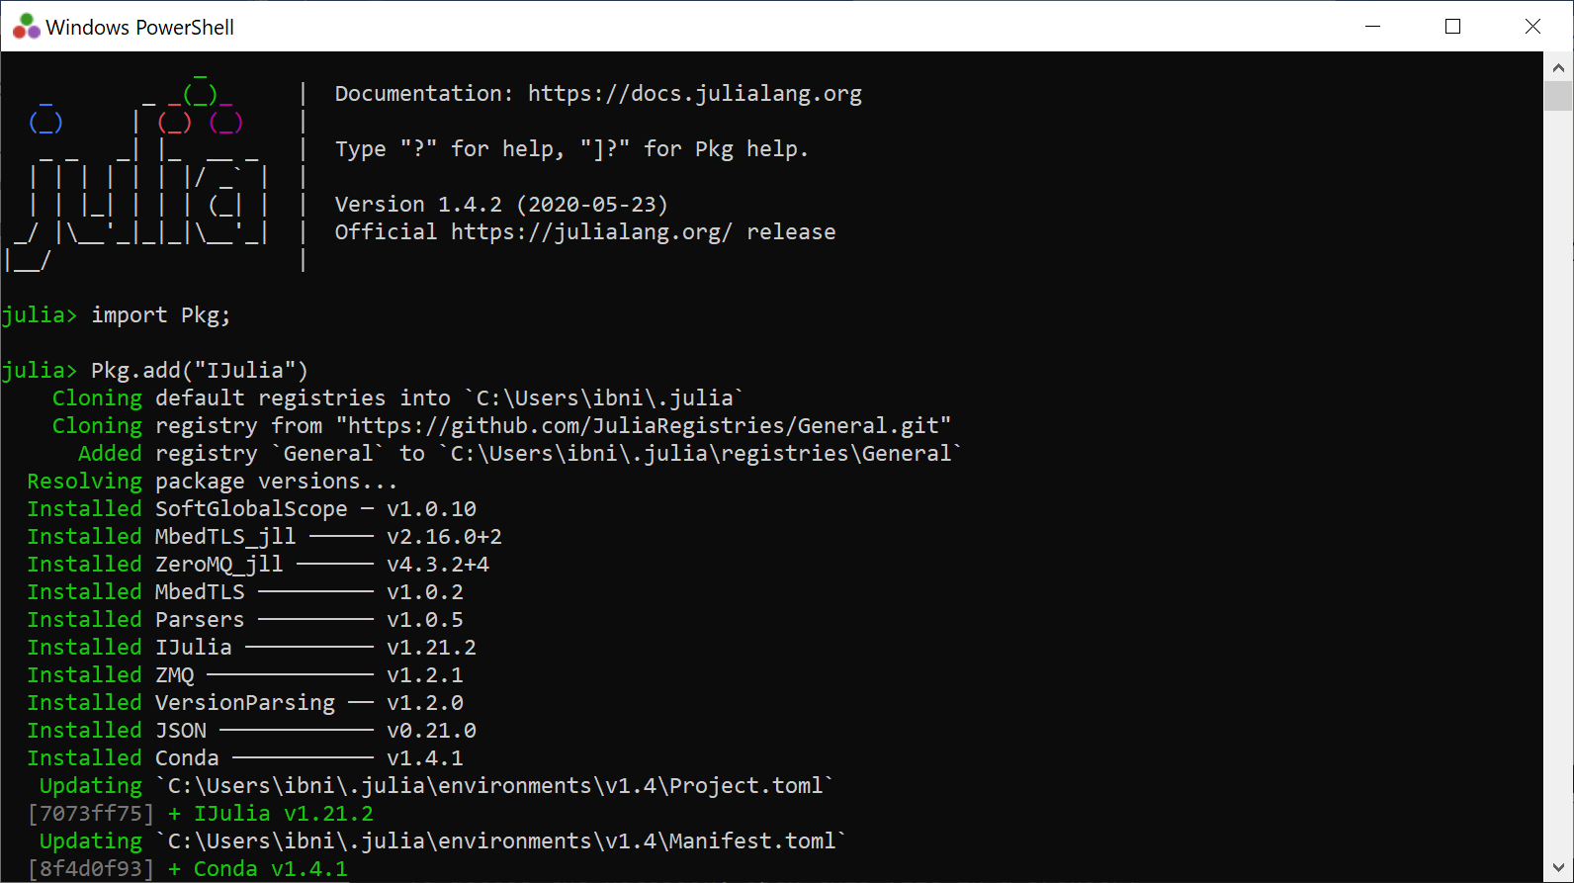

This ensures that Julia and Jypyter (in mysterious ways) are connected.

After, download the following packages (while still in the Julia window) needed by DDD. Write:

Pkg.add("CSV")

Pkg.add("Distributions")  
Pkg.add("LsqFit")  
Pkg.add("Statistics")  
Pkg.add("Dates")  
Pkg.add("DataFrames")

Pkg.add("BlackBoxOptim")  
Pkg.add("Plots")

The package «IJulia» must be installed before you can open a notebook.

We run the model using the run script, “RunDDDEvent”. I have put the «Run script» on my One-drive (from experience it seems to be easily accessible from Jyputer).

Now open unDDDEvent.ipynb in notebook and edit all the paths so that they can be found by the program dem. The top of RunDDDEvent looks like this:

Check and make sure the file paths work on your computer. An important function is the “DDDEventFloodDesign.jl” function, which contains the main routines for the DDDEvent model.

Remember to save (ctrl s)

Run the model for the catchment 123.38 (Risvollan in Trondheim, Norway) to check that everything works. Remember to edit paths so the the runscript finds the parameterfile (paramfile) and where to place the resultfiles (utfile and utfile2).

The number of events you want to simulate can be specified with the parameter “Numsim”.

You start the script, i.e. run the model by “ctrl Enter”

***NB Julia must be started in order to run the model***

After (quite) a few seconds (depends on the number of events (100000 events took 177 seconds, about 3 minutes), and the following appear on the screen at the bottom:

**3) Describing the input data**

The parameter file is the sole input data and is a *.csv file. The following shows the parameter file with comments and a suggestion on how to estimate.

The parameter fil with comments

|  |  |  |  |
| --- | --- | --- | --- |
| **Name** | **Value** | **What** | **How to estimate** |
| Urban | 1 | Any number for value |  |
| Pkorr | 0.77 | Correction of precip [-] | Calibrated from DDDv2 |
| Timeresinsec | 180 | Timeresolution in seconds [s] |  |
| MAD | 0.0035 | Annual mean discharge [m³/s] | Measure/Calibrate |
| Area | 178340 | Area in [m²] | GIS |
| NoL | 2 | No of layers , 1 overland lag and 1 subsurface layer [-] | Fixed |
| R | 0.3 | Field cap., degree of saturation before percolation to saturated zone [-] | Fixed |
| Pfrac | 0.775 | Fraction permeable areas [-] | GIS |
| IPfrac | 0.225 | Fraction impermeable areas [-] | GIS |
| Pmax | 55.3 | Max distance permable areas [m] | GIS |
| IPmax | 53.2 | Max distance impermable areas [m] | GIS |
| Pmid | 11.4 | Mean distance permeable areas [m] | GIS |
| IPmid | 11.3 | Mean distance impermable areas [m] | GIS |
| Pz | 0.05 | Areafraction of 0 m distance to rivernetwork, permeable area [-] | GIS |
| IPz | 0.06 | Areafraction of 0 m distance to rivernetwork, impermeable area [-] | GIS |
| midFl | 431.8 | Mean distance in rivernetwork [m] | GIS |
| stdFl | 178.5 | Standard deviation distance in rivernetwork [m] | GIS |
| maxFl | 836.9 | Max distance in rivernetwork [m] | GIS |
| OFVP | 0.002 | Overland flow celerity [m/s] permable areas | Calibrate/litterature/measure |
| OFVIP | 0.005 | Overland flow celerity [m/s] impermable areas | Calibrate/litterature/measure |
| GshInt | 1 | Shape par. for dist. of recession charact.: for subsurface and overland fl.velocities [-] | Fixed |
| GscInt | 0.002 | Shape par. for dist. of recession charact.: for subsurface and overland fl.velocities [-] | Calibrated from DDDv2 |
| Rv | 1.55 | Water celerity in river network [m/s] | Measure/Calibrate |
| Persons | 0 | Number of persons with water use [180 L/day/person] , external water | Measure/estimate |
| Precresinsec | 900 | Critical duration for extreme precipitation in seconds- same as catchment concentration time (K. Imhoff, 1922) | Measure/estimate |
| Gploc | 2.22 | Location parameter, Generalised Pareto distribution (GPD) for extreme precipitation. | Measure/estimate |
| GPsc | 1.25 | Location parameter, GPD for extreme precipitation | Measure/estimate |
| GPsh | 0.19 | Location parameter, GPD for extreme precipitation | Measure/estimate |
| SMSh | 1 | Shape parameter Gamma distributed groundwater state (fixed as 1.0 gives exponential distribution). We have chosen the exponential distribution because it allows for zero’s | Measure/estimate from DDDv2 simulations |
| SMSc | 1.8 | Scale parameter Gamma distributed groundwater state (Shape = 1.0 gives exponential distribution) | Measure/estimate from DDDv2 simulations |
| ICapP | 200 | Infiltration capacity [mm/hour], permeable areas | Measure/estimate |
| ICapIP | 1 | Infiltration capacity [mm/hour], impermeable areas | Measure/estimate |

The DDDEvent model has no input data file of precipitation. Precipitation values are drawn from the statistical extreme values distribution Generalised Pareto Distribution (GDP).

**6) Output**

DDDevent produces two output files. “simres…” and “simres2 …” . In the current version (July 2024) of DDDEvent, each row describes an event, and the columns for “simres….” are:

1: "TimestpMaxFld", which time step gives the maximum flow

2: "ExtprecipDur", The precipitation event of critical duration drawn from the GPD [mm]

3: "maxQ",

4: "maxQ_P",

5: "maxQ_IP",

6: "SST_P", precipitation [mm]

7: "SST_IP", temperature [°C]

8: "Def_P", observed runoff [m³/s]

9: "Def_IP", simulated total runoff [m³/s]

10: Qmm

11: XX

12: "SS_P", simulated runoff P-area [m³/s]

13: "SS_IP", simulated runoff IP-area [m³/s]

14: "OF", simulated runoff wetlands [m³/s]

15: "OF_P", Snow covered area P-area[fraction]

16: "OF_IP", Snow water eqauivalent P-area [mm]

17: "SSF_P", Storage subsurface, P-area [mm], inkl overland flow

18: "SSF_IP", Storage subsurface, IP-area [mm], inkl overland flow

19: "InitSS", Subsurface deficit P- area [mm]

20: "Shp1", Subsurface deficit IP-area [mm]

21: "Shp2", soilwater (unsaturated zone) P-area [mm]

22: "TimesetpMaxPrec", soilwater (unsaturated zone) IP-area [mm]

23: "PrecipMax", Maximum precipitation per timestep [mm]

To read and plot from the result file, use, for example, an R script.

In the “simres2 …” we find short time series (i.e. the time of duration + equal timelength for the recession) for each event. Per (July 2024) we have the time series for: precipitation, runoff, subsurface water content, runoff only due to initial conditions and runoff minus runoff due to initial conditions. The time series can be instructive to illustrate the contributions from the precipitation event and the initial subsurface conditions for the different events.

**References**

Skaugen, T. D. Lawrence and R. Z. Ortega, 2020. A parameter parsimonious approach for catchment scale urban hydrology – Which processes are important?. Journal of Hydrology X, 8, <https://doi.org/10.1016/j.hydroa.2020.100060>

Skaugen, T. and Weltzien, I. H., 2016. A model for the spatial distribution of snow water equivalent parameterised from the spatial variability of precipitation, *The Cryosphere*. 10, 1947-1963, doi:10.5194/tc-10_1947_2016.

Tsegaw, A.T., Skaugen, T, Alfredsen, K & Muthanna, T.M: [A dynamic river network method for the prediction of floods using a parsimonious rainfall-runoff model](https://iwaponline.com/hr/article/doi/10.2166/nh.2019.003/69546/A-dynamic-river-network-method-for-the-prediction). Hydrology Research 2019; doi.org/10.2166/nh.2019.003, ISSN 1998-9563 (Published online August 26 2019).